T1: Write in code so if page is full size it looks like:

<https://github.com/ardakshalkar/foundationsofweb2017tasks/blob/master/week3/letters.html>

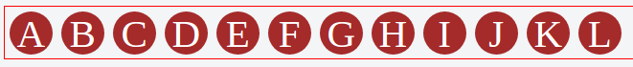

And when you change size of windows, they are wrapped like in following image

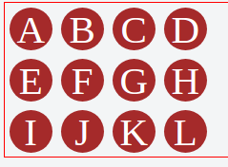

T2: Change HTML code so that it looks like in image

<https://github.com/ardakshalkar/foundationsofweb2017tasks/blob/master/week3/page_layout.html>



T3: Page (<https://github.com/ardakshalkar/foundationsofweb2017tasks/blob/master/week3/page_layout_full.html> ) should look like:

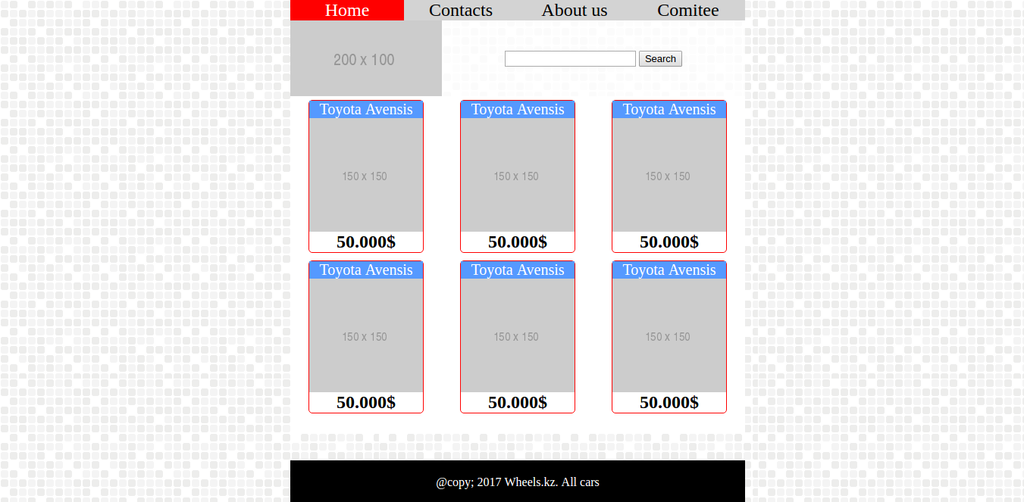

Footer should be sticked, read how to do it in following page:

<https://philipwalton.github.io/solved-by-flexbox/demos/sticky-footer/>

When mouse comes over menu links, they get red background and white text color

Background image url: <http://backgroundlabs.com/wp-content/uploads/2013/04/subtle-mosaic-pattern.png>